

Topic test 2
Name: __________________________________

Chapter 12: Graphs

• Time allowed: 45 minutes
• CAS calculators may be used.
• Part A: 7 multiple-choice questions (7 marks)
• Part B: 11 short answer questions (44 marks)
• Part C: 2 analysis questions (29 marks)
Part A
7 multiple-choice questions
1 mark each: 7 marks
Circle the correct answer.
1 The gradient of the line with the equation y = −3 − 5x is:
A 5
B 3
C −3
D −5
E
[1 mark]
2 Which of the following is not true for 2y = 8 + 10x
A The line has a gradient of 5.
B The line is steeper than the line for the equation y = x.
C The point (1, 9) lies on the line.
D The line has a positive gradient.
E The line has a y-intercept of 8.
[1 mark]

3 The equation of the line with a gradient of 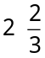 and a y-intercept of −3 is:
A 2x − 3y = 9
B 2x − 3y = −9
C 3x + 2y = −9
D 2x + 3y = −9
E 3x − 2y = 9
[1 mark]
4 The coordinates of the x- and y-intercepts respectively for the equation
5x − 3y = −30 are:
A (−6, 0) and (0, 10)
B (6, 0) and (0, 10)
C (−6, 0) and (0, −10)
D (5, 0) and (0, −3)
E (0, −6) and (10, 0)
[1 mark]
5 The coordinates of the point of intersection of the lines below are:
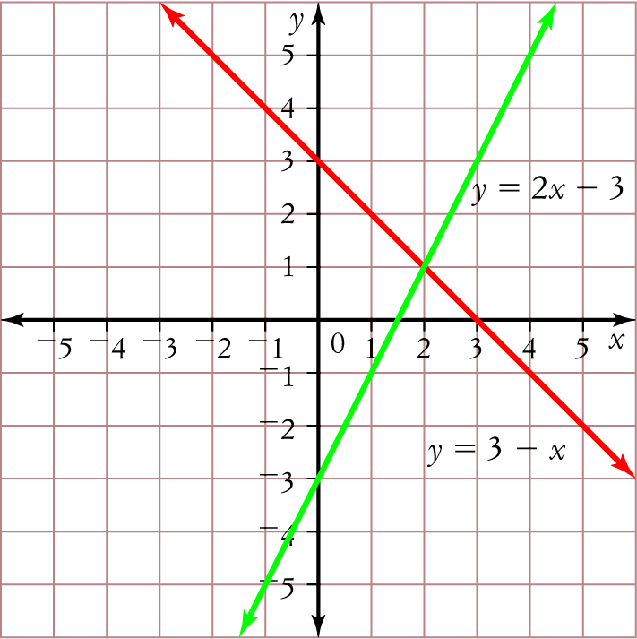
A (1, 2)
B (2, 1)
C (3, 0)
D (0, −3)
E (2, −1)
[1 mark]
6 The solution to the simultaneous linear equations is:
y = 7x + 11
y − 3x = −5
A x = 4, y = 39
B x = −4, y = −17
C x = −17, y = −4
D x = −4, y = 39
E x = 4, y = 17
[1 mark]
7 The step graph below shows the cost of sending a parcel to New Zealand by air.
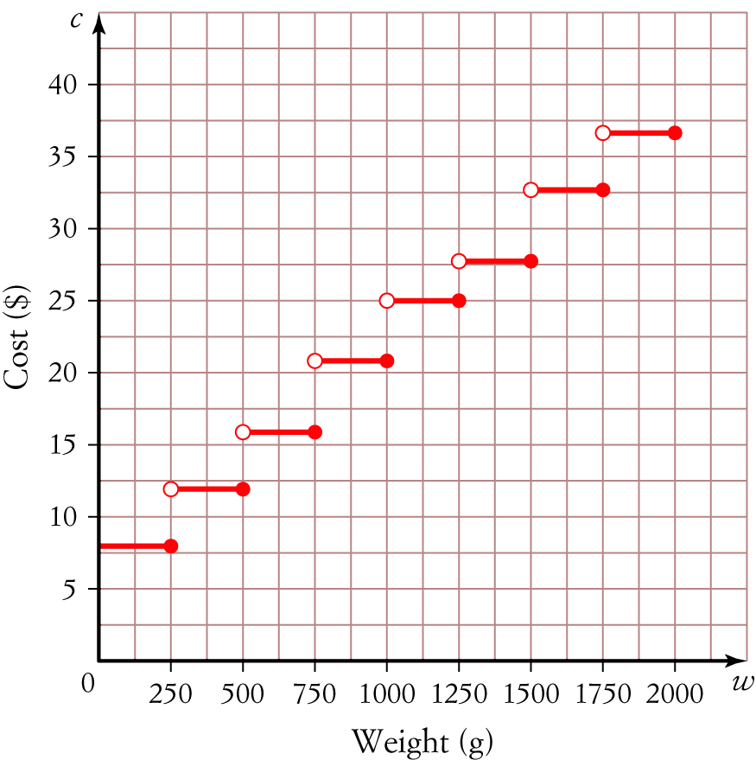
The total cost of sending a parcel weighing 750 g and a parcel weighing 1.8 kg is
A $45
B $58
C $53
D $16
E $37
[1 mark]

Part B
11 short answer questions
44 marks
Show your working where appropriate.
Where necessary give all answers to two decimal places.
1 Express the equation 5x + 4y − 14 = 0 in the form y = a + bx and hence state the gradient and y-intercept of
the line.

[3 marks]
2 Find the equation of the line passing through the points ( −5, 7) and (0, 3).

[5 marks]
3 Determine the x- and y-intercepts of the equation 7x − 4y = 28 and hence sketch its graph.

[3 marks]
4 The graph shows the fees charged by a plumber.
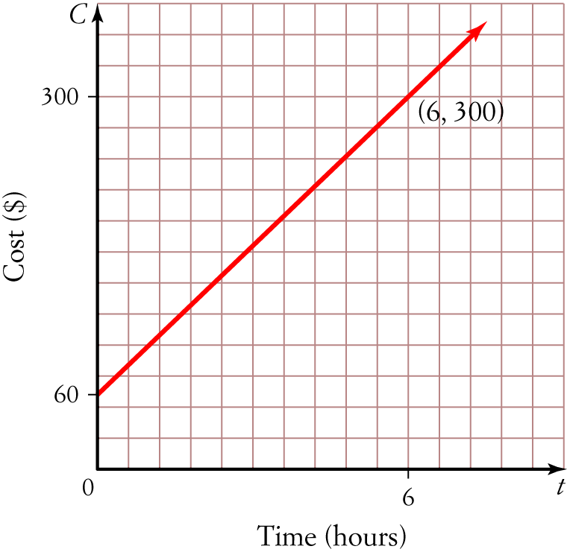
a What is the vertical intercept and what might it represent?

b State the gradient of the line.

c Write an equation for the line using your answers to parts a and b.

[4 marks]
5 Sketch the graphs of y = 2 +x and x = 4 on the same set of axes. State the coordinates of their point of intersection.

[4 marks]

6 Solve the simultaneous linear equations below using the substitution method.
y = −9 + 4x
y = 5 − 3x

[4 marks]
7 Use the process of elimination to solve the simultaneous linear equations:
4x − 3y = 3
3x − 5y = −6

[4 marks]

8 The sum of two numbers is 42 and their difference is 34.
a Write a pair of simultaneous linear equations to represent this information.

b Solve the equations simultaneously to find the two numbers.

[4 marks]

9 Sketch the graph of the stepwise linear equation below.
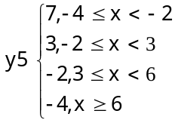

[3 marks]
10 A taxi driver charges $20 flag fall and $4 per kilometre or part thereof.
Construct a step graph to represent the taxi driver’s charges for the first 6 kilometres.

[3 marks]
11 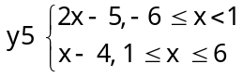
a How many line segments form this piecewise linear graph?
b What is the gradient of each line segment?

c Which line segment is steeper? Why?

d Sketch the graph of the piecewise linear equation given above.

[7 marks]
Part C
2 analysis question
29 marks
Show your working where appropriate.
1 The piecewise linear graph below shows the volume of water in a water tank over 24 hours.
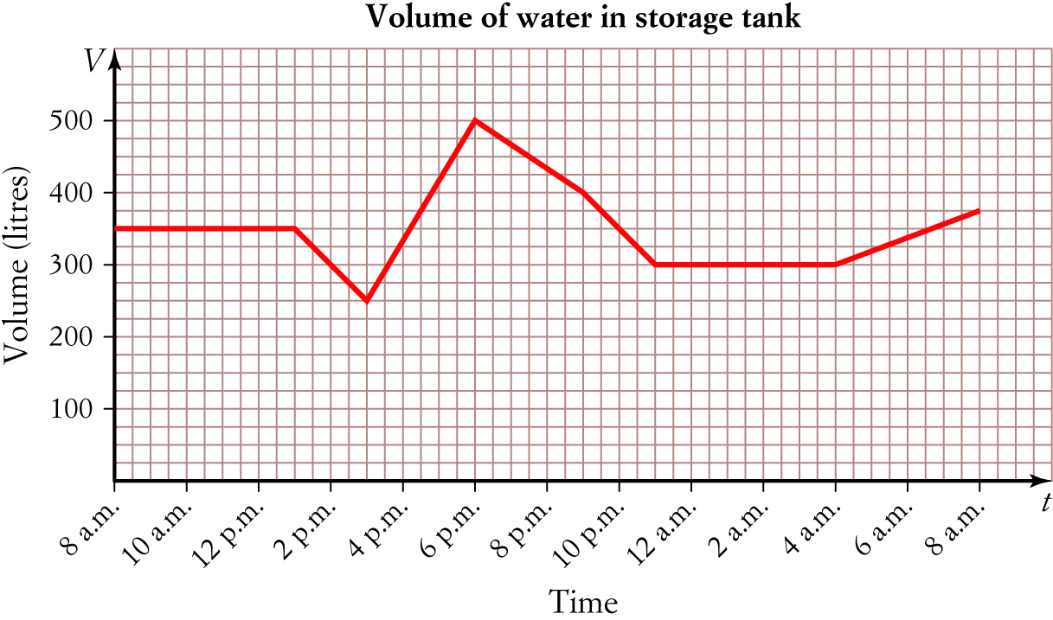
a What is the vertical intercept for this graph. What does this intercept represent?

b What is volume of water at
i 3 p.m.? __________________________________________________
ii 9 p.m.? __________________________________________________
iii 8 a.m. (the day after)? __________________________________________________
c At what time/s was the volume of water
i 500 litres? __________________________________________________
ii 400 litres? __________________________________________________
iii 150 litres? __________________________________________________
d What is the difference in the volume of water in the tank between 3 p.m. and 10 p.m.?

e Between what time is the water tank filling the fastest? Explain your answer.

f Between what times is the level of water in the tank falling? Explain your answer.

g i What is the gradient of the line between 8 a.m. and 1 p.m.?

ii What does this tell us about the rate the water is filling between this time?

h Determine the gradient of the remaining line segments.

[18 marks]
2 Matthew owns a video rental store. His monthly costs of purchasing n new DVDs for his video shop
is C = 18n + 532, while his monthly income from renting out those new DVDs is I = 46n, where C and I are in dollars.
a What is the vertical intercept of the Cost graph and what does it represent?

b Graph both functions for values of n from 0 to 40 and find the break-even point.

c What would happen if the store bought fewer DVDs than the break-even value of n?

d Calculate the monthly cost of purchasing 35 DVDs and the income earned from these.

e According to the formula, what monthly income is earned from each new DVD?

[11 marks]
Total marks: 80

Answers
Part A [1 mark each]
1 General form of an equation is y = a  bx, where a is the y-intercept and b = gradient.
For y = −3 − 5x, a = −3 and b = −3, therefore gradient = −5.
∴E
2 2y = 8  10x
y = 4  5x
y-intercept = 4, gradient = 5
A True: 2y = 8  10x, gradient is 5.
B True: 2y = 8  10x has a gradient = 5; y = x has a gradient = 1.5 > 1, hence 2y = 8 + 10x is steeper than y = x.
C True:
2 × 9 = 8 + 10 × 1
18 = 8 + 10
18 = 18 ✓
D True: gradient = +5
E Not true: y-intercept = 8
∴ E
3 a = −3, b =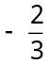
Substitute a and b into y = a + bx.
y = 3 x
3y = 9  2x
2x + 3y = −9
∴ D
4 x -intercept: let y = 0
5x − 3 × 0 = −30
5x = −30
x = −6
Coordinates: (−6, 0)
y-intercept: let x = 0
5 × 0 − 3y = −30
−3y = −30
y = 10
Coordinates: (0, 10)
∴ A
5 Locate the point of intersection (that is the point where the two lines cross). Read the coordinates from the graph.
Coordinates are (2, 1)
∴ B
6 y = 7x + 11 [1]
y − 3x = −5 [2]
Substitute [1] into [2]
7x + 11 − 3x = −5
4x + 11 = −5
4x = −16
x = −4
Substitute x = −4 into [1]
y = 7 × −4 + 11
y = −28 + 11
y = −17
Solution is x = −4, y = −17
∴ B
7 The 750 g parcel will cost $16 to send.
The 1.8 kg (1800 g) will cost $37 to send.
Total cost = $16 + $37
= $53
∴ C
Part B
1 5x + 4y − 14 = 0
4y = 14 − 5x
y = − x [1 mark]
a = , b = − [1 mark]
∴ gradient = −, y-intercept = [1 mark]
2 Let (x₁, y₁) = (−5, 7) and (x₂, y₂) = (0, 3)
b =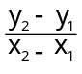
=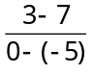 [1 mark]
= − [1 mark]
(0, 3) are the coordinates of the y-intercept.
∴ a = 3 [1 mark]
Substitute a = 3 and b = −into y = a + bx
y = 3 −x [1 mark]
5y = 15 − 4x
4x + 5y = 15 [1 mark]

3 Let x = 0, 7 × 0 − 4y = 28
− 4y = 28 [1 mark]
y = −7
Let y = 0, 7x − 4 × 0 = 28
7x = 28 [1 mark]
x = 4
x-intercept = 4, y-intercept = −7
Plot the x- and y-intercepts.
Join these points to sketch the line. Extend the line.
Remember to write the equation of the line next to its graph.
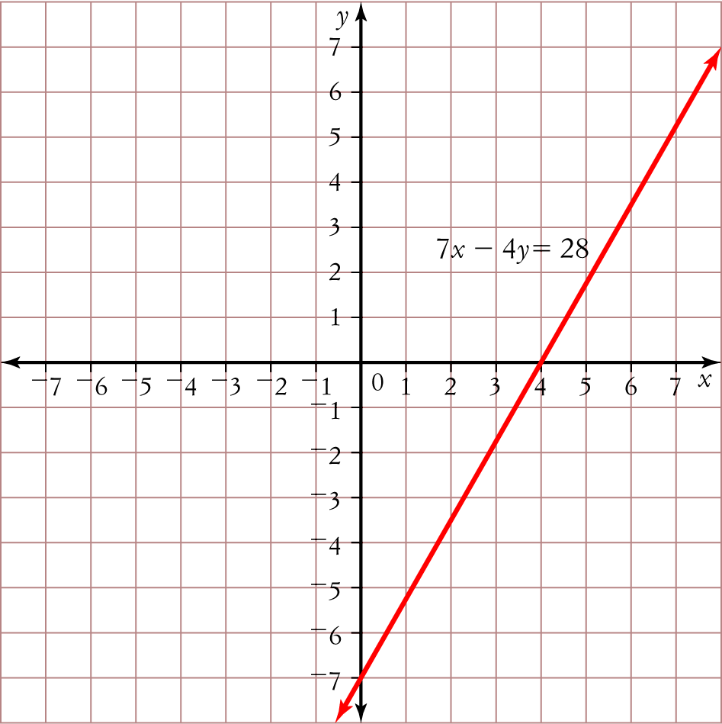 [1 mark]
4 a $60; Vertical intercept represents the call out fee for the plumber.
b gradient = 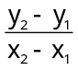
= 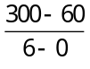 [1 mark]
= 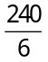
= 40 [1 mark]
c Equation will be in the form y = a + bx, where a = 60 and b = 40.
∴ C = 60 + 40t [1 mark]
5 The equation y = 2 + x is written in the form y = a + bx. Use the gradient and y-intercept method to sketch its graph.
gradient = y-intercept = 2 [1 mark]

The equation x = 4 is in the form x = a. There is no y-value present in the equation, hence the graph is a line parallel to the y-axis. The x-intercept is 4. [1 mark]
Sketch both lines on the same set of axes.
Remember to write the equation of the line next to its graph.
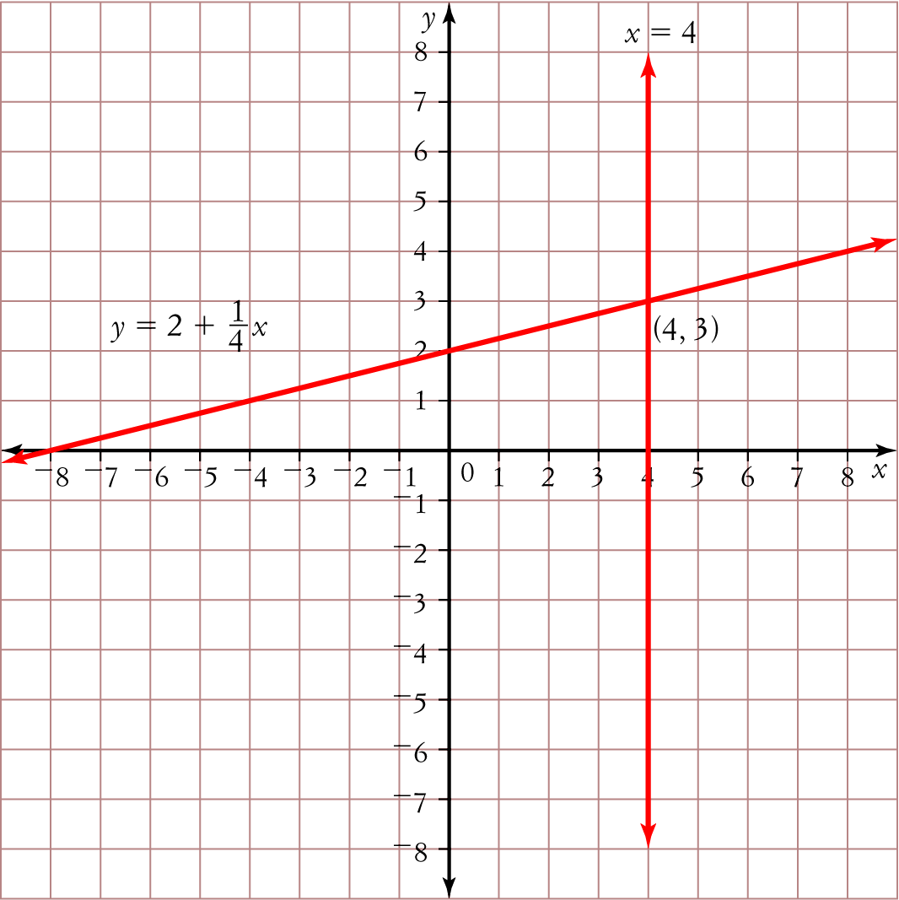 [1 mark]
Point of intersection is (4, 3). [1 mark]
6 y = −9 + 4x [1]
y = 5 − 3x [2]
Substitute [1] into [2]
−9 + 4x = 5 − 3x [1 mark]
−9 + 7x = 5
7x = 14
x = 2 [1 mark]
Substitute x = 2 into [1]
y = −9 + 4 × 2
y = −1 [1 mark]
Check the answer.
[1] −1 = −9 + 4 × 2
−1 = −9 + 8 ✓
[2] −1 = 5 − 3  2
−1 = 5 − 6 ✓
The solution is x = 2 and y = −1. [1 mark]

7 4x − 3y = 3 [1]
3x − 5y = −6 [2]
[1] × 5 20x − 15y = 15 [3]
[2] × −3 − 9x + 15y = 18 [4] [1 mark]
[3] + [4] 11x = 33
x = 3 [1 mark]
Substitute x = 3 into [1]
4 × 3 − 3y = 3
12 − 3y = 3
− 3y = −9
y = 3 [1 mark]
The solution is x = 3 and y = 3. [1 mark]
8 a Let x = first number and y = second number
x + y = 42
x − y = 34 [1 mark]
b x + y = 42 [1]
x − y = 34 [2]
[1] + [2]
2x = 76
x = 38 [1 mark]
Substitute x = 38 into [1]
38 + y = 42
y = 4 [1 mark]
The two numbers are 38 and 4 [1 mark]
9 There are 4 line segments (or steps) to the graph.
Draw a horizontal line from −4 to −2 at 7. −4 is included but −2 is not, so place a closed circle at the start and an open circle at the end of the segment.
Draw a horizontal line from −2 to 3 at 3. −2 is included but 3 is not, so place a closed circle at the start and an open circle at the end of the segment.
Draw a horizontal line from 3 to 6 at −2. 3 is included but 6 is not, so place a closed circle at the start and an open circle at the end of the segment.
Draw a horizontal line starting from 6 at −4. 6 is included, so place a closed circle at the start of the line and an arrow at the end to show that the line continues to infinity.

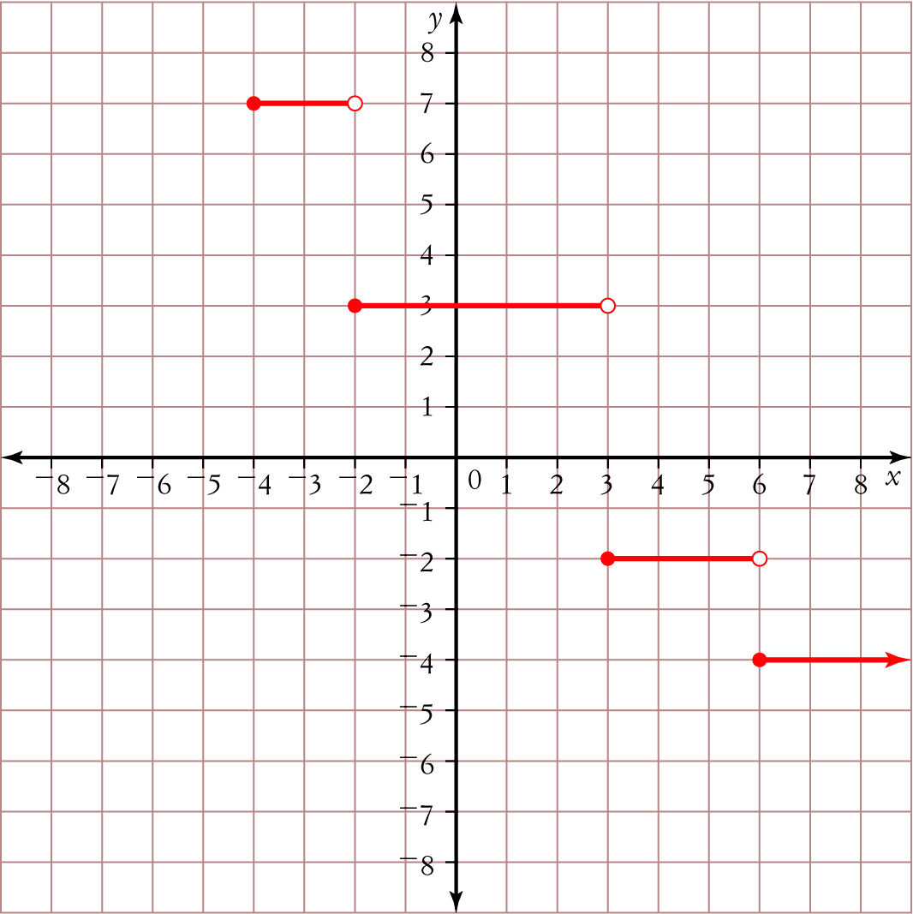
[1 mark for placing line segments in correct position]
[1 mark for placing open/closed circles/arrow correctly at end of line segments]
[1 mark for presentation of graph/ labelling etc.]
10 Horizontal axis labelled d (distance), with scale increasing by 1 from 1 to 6.
Vertical axis labelled $C (cost), with scale increasing by 2 from 0 to 50. [1 mark]
Vertical intercept = 15 [1 mark]
Line segments drawn correctly with open circles at start and closed circles at end. [1 mark]
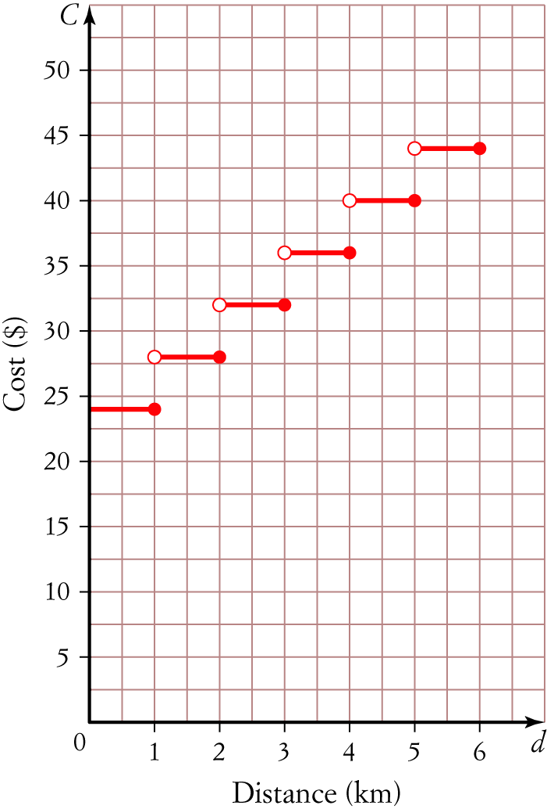
11 a 2 line segments [1 mark]
b y = 2x − 5; gradient = 2
y = x − 4; gradient = 1 [1 mark]
c y = 2x − 5 is steeper. [1 mark]
It has a gradient of 2 compared to 1. The larger the gradient the steeper the line. [1 mark]
d Sketch y = 2x − 5 for x-values between −6 and 1.
gradient = 2, y-intercept = −5
End points are:
x = −6, y = 2 × −6 − 5
y = −17
(−6, −17)
x = 1, y = 2 × 1 − 5
y = −3 [1 mark]
(1, −3)
Sketch y = x − 4 for x values between 1 and 6.
gradient = 1, y-intercept = −4
x = 1, y = 1 − 4
y = −3
(1, −3)
x = 6, y = 6 − 4
y = 2 [1 mark]
(6, 2)
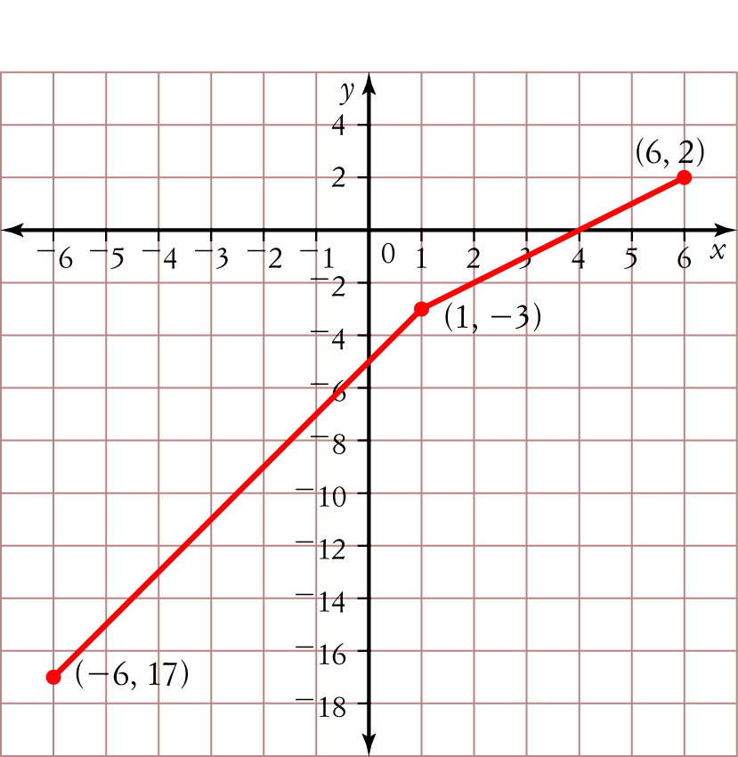
[1 mark for labelling/presentation/scale]
Part C
1 a 350 litres [1 mark]
Level of water in the tank at 8 a.m., that is when level of water is first measured. [1 mark]
b i 250 litres
ii 400 litres
iii 75 litres
[1 mark + 1 mark + 1 mark  3 marks]

c i 6 p.m.
ii 5 p.m. and 9 p.m.
iii water levels did not fall to 150 litres.
[1 mark + 1 mark + 1 mark  3 marks]
d water level at 3 p.m. = 250 litres; water level at 10 p.m. = 350 litres
Difference = 350 − 250
= 100 litres [1 mark]
e Between 3 p.m. and 6 p.m.
[1 mark]
The gradient is the steepest between these times.
[1 mark]
f Between 1 p.m. and 3 p.m. and between 6 p.m. and 11 p.m. [1 mark]
The gradient is negative, hence the water levels are falling. [1 mark]
g i gradient = 0 [1 mark]
ii Water levels did not change during this time, i.e. rate is 0 litres/hour.
[1 mark]
h Between 1 p.m. and 3 p.m. gradient = −50
Between 3 p.m. and 6 p.m. gradient = 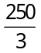
Between 6 p.m. and 9 p.m. gradient = 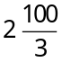
Between 9 p.m. and 11 p.m. gradient = −50
Between 11 p.m. and 4 a.m. gradient = 0
Between 4 a.m. and 8 a.m. gradient =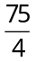 [3 marks]
2 a 532, the fixed cost in dollars of buying new DVDs. [1 mark]
b C = 18n + 532; Vertical intercept = 532, gradient = 18 [1 mark]
I = 46n; Vertical intercept = 0, gradient = 46 [1 mark]
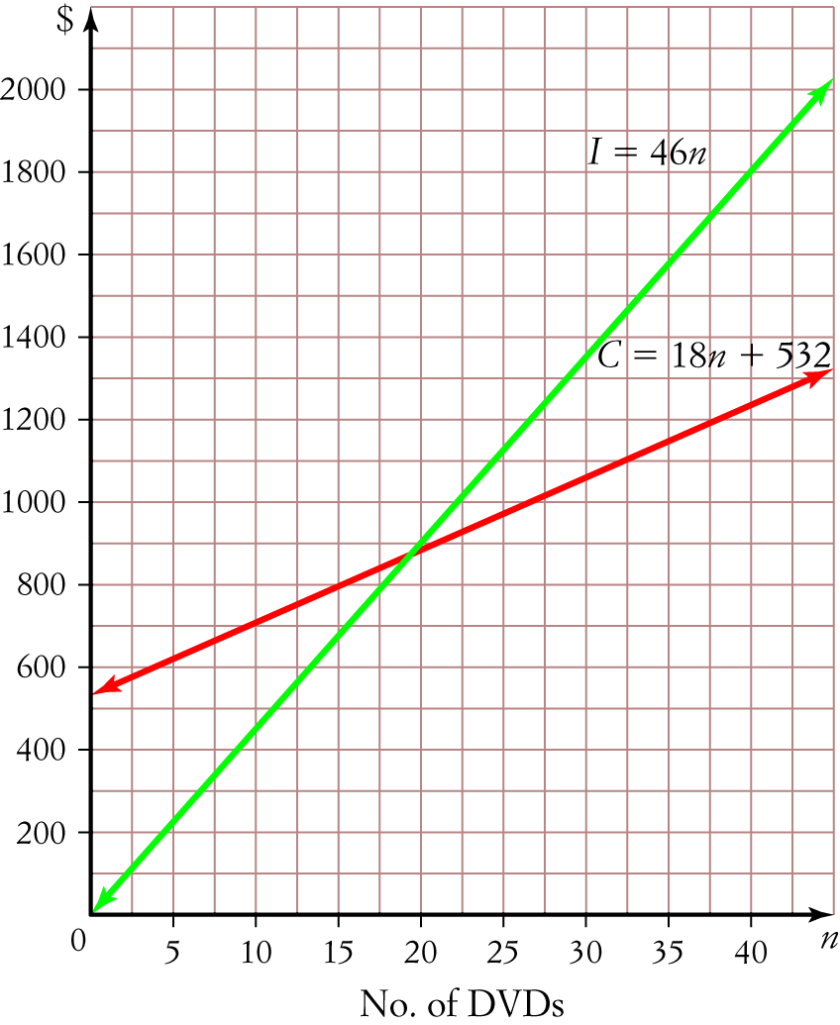
[1 mark for labelling and accuracy of graph]
Break-event point: (19, 874) [1 mark]
c They would make a loss: the monthly cost would be more than the monthly income. [1 mark]
d C = 18n + 532
C = 18 × 35 + 532
C = 1162 [1 mark]
I = 46n
I = 46 × 35
I = 1610 [1 mark]
Monthly cost = $1162, Monthly income = $1610
[1 mark + 1 mark = 2 marks]
e I = 46n, Gradient is 46, therefore each DVD will earn $46 per month.
[1 mark]

